### CURRICULUM VITAE

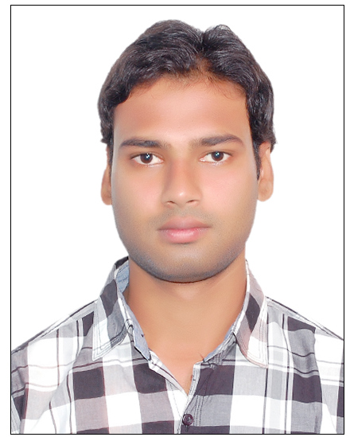

**MD. NAUSHAD**

**Sanctoria Bazar**

**Dishergarh**

**West Bengal**

**Mob: +91 7029978855**

**Whats App: +91 7029978855**

**Email:naushadamaan@gmail.com**

**Passport details- No - L7672581**

**Issue date- 07/03/2014**

**Expiry date-06/03/2024**

**Post Applied For:- Programmer Analyst Tranee**

## Career Objective

To be a part of an organization and dedicate my entire proficiency and skills for the development of company along with improving my knowledge. My dedication toward work and want for learning new things will make me a good candidate.

## Additional Skills

Excellent communication skills in English, Hindi.

Ability to multi task in a demanding engineering environment. A strong track record in delivering projects on time and within budget able to ensure that all safety procedure is meet and maintained.

## Summary of Education

|  |  |  |  |  |
| --- | --- | --- | --- | --- |
| **Sl. No** | **Stream** | **College/University** | **Percentage** | **Year** |
| 1 | B.Tech(Mechanical Engineering) | K C College Of Engineering and Information Technology/ Punjab Technical University | 65% | 2009-2013 |
| 2 | Science (H.S) | ISC/ De Nobili School Mugma | 62% | 2009 |
| 3 | Science (Matriculation) | ICSE/ De Nobili School Mugma | 70% | 2007 |

## Software skills

|  |  |  |  |  |
| --- | --- | --- | --- | --- |
| **Sl. No.** | **Skills** | **From** | **Organization** | **Duration** |
| 1 | Data Science Architecture | Apr 2020 - May 2020 | iNeuron | 1 Month |
| 2 | Power BI Masters | Apr 2020 - May 2020 | iNeuron | 1 Month |
| 3 | Python for Data Science | Apr 2020 - May 2020 | iNeuron | 1 Month |
| 4 | Tableau Masters | Apr 2020 - May 2020 | iNeuron | 1 Month |
| 5 | Machine Learning Masters | Mar 2020 - Oct 2020 | iNeuron | 7 Months |

## Summary of Work Experience from 2013 to Present.

**Sl. No. Company Designation From Up to Total**

|  |  |  |  |  |  |
| --- | --- | --- | --- | --- | --- |
| 1 | Wipro Ltd. | Tech. Support Associate | 12th November,2019 | 03rd November, 2020 | 1 Year |
| 2 | Woohyeon India Pvt. Ltd.(KIA Motors Project) | QA/QC and MEP Engineer | 10th August, 2018 | 31st January, 2019 | 6 Months |
| 3 | Al Mariah United Group, Abu Dhabi | HVAC Supervisor | 30th September, 2017 | 22nd April, 2018 | 7 Months |
| 4 | TAYO Rolls Ltd. (Contractual basis) | MEP Project Engineer | May 2013 | 10th August, 2016 | 3 Years 3 Months |

**Wipro Ltd**

* Worked as L3 Technical Associate.
* Solving computer related issue of US Clients.
* It was a non-Voice process.
* Understanding the issues of Clients.
* Providing solutions for their electronic components such as Computer, Laptop, Printer, Smart Television, Refrigerator, and Other Gadgets.

**WooHyeon Enterprises India Pvt. Ltd. (A contractor of Hundai Engineering Constructions) At KIA MOTORS Project, ANANTAPUR**

**As a QA/QC and MEP Engineer. From 10-8-2018 to 31-01-2019.**

* Responsibilities includes maintaining and insuring the quality as expected by HEC Client.
* Checking all the materials and insuring the qualities as demanded.
* Also active at site as a Site Engineer.
* My works as a Site Engineer includes (**i) Installation of Ducts (ii) Installation of Pipes for firefighting Underground. Piping and (iii) Plumbing work .i.e. Sanitary Fittings Installation and Water Line piping and Sewage Pipe line Installation.**
* At site organizing meeting with Foreman’s and giving them their duties at the same time clearing their doubts, if any.

**Al Mariah United Group Abu Dhabi from September 2017 to April 2018.**

* Working as a HVAC Maintenance Supervisor in Hospital Project.
* Maintenance of Chillers, FCUs, Package Units, AHUs, Split AC Units, Ducts and Piping Systems.
* Also maintenance of Fire Fighting System like Maintenance of Pumps and Pipes.
* Changing of Valves and pipes where necessary.
* Following instructing of SEHA (Government of Abu Dhabi Hospitals) and implying to worker.
* Responsible for maintaining HVAC system history records, failures and analysis records.
* Responsible for planning and execution of preventive maintenance, breakdown maintenance and plant shut down activities.
* Responsible for proper documentation of maintenance related works and spares management.

**TAYO ROLLS LTD. Gamariya (Contratual)**

**Contractor Puranmal Engineers.**

* Worked as a **Mechanical Project Engineer** at TAYO ROLLS LTD. Gamariya and other sites. The work carried out are as follows: -
* Worked in **Three Greenfield project** and **Seven Brown Field Projects.**
* Installation and commissioning of Annealing Furnace both Oil fired and Gas fired.
* Installation of Gas Pipe lines.
* Responsible for scheduling checks on Piping system, finding and fixing faults, overhauling and replacing part according to schedule.
* Planning for manpower, running spares on Furnace system,
* Maintenance and Installation of COMPRESSOR, PUMPS, DIESEL GENERATORS.
* Research, design, evaluate, install, operate, and maintain mechanical products, equipment, systems and processes to meet requirements, applying knowledge of engineering principles.
* Confer with engineers or other personnel to implement operating procedures, resolve system malfunctions, or provide technical information.
* Responsible for safety of person and equipment at site.

### Personal Information

Fathers Name : ABDUL RAJAK

Gender : Male

Date of Birth : 11-10-1991

Nationality : Indian

Linguistics Proficiency : English, Hindi, Bengal, Urdu

DATE**:**

PLACE: Asansol (MD. NAUSHAD )